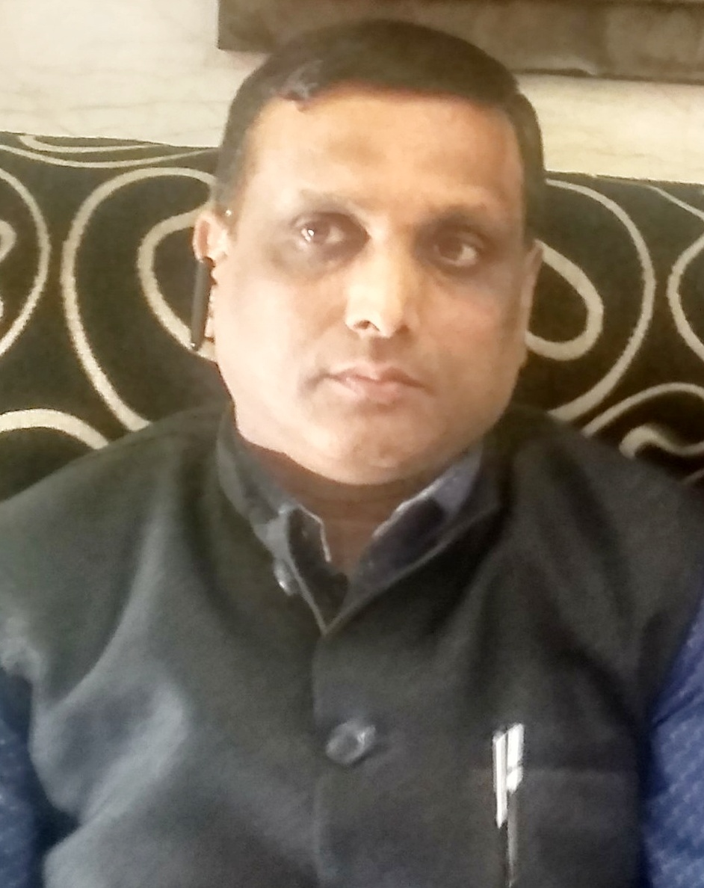

Curriculum Vitae

Neeraj Gupta

M-16,GF, NEAR JASROTIA HOSPITAL,

HARI NAGAR (MAYAPURI) NEW DELHI-110064.

PH. : 9213235449

CAREER OBJECTIVE

A highly motivated, confident with exceptional multi-tasking and organisational skills
Professional Overview: Working as an Accounts-Head Handled a team of 12 associates with good understanding , Team management and team building skills , attrition control, and good analytical and interpersonal skills.
A self motivated ,Determined & Responsible ,who is able to consider all option with an open mind before making a decision. Moreover, I am an effective team leader with good problem solving skills & always look forward for professional growth and new challenges. Expertise in working in fast paced challenging market with more than 24 years of rich experiences of Operation , Banking , Accounts & Finance , Business Development.

EXPERIENCE IN A/C’S :

WORK EXPERIENCE

PRESENTLY WORKING WITH EXPORT TRADING HOUSE,

A LIMITED CO. AT NSP,PITAMPURA, NEW DELHI ,AS AN HEAD-ACCOUNTS , WORKING FROM APRIL 2010

Responsibilities & Key profile

LEADING TEAM OF 12 PEOPLE , Taking care of Accounts Deptt.
( Contorlling multiples branch in DELHI (HO) and Branch in Gandhidham-Bundi-Kerala-Sonepat/Mangalore )

Taking care of correspondence, reconciliation, analysis, settlement of disputes, management information system & executing month end close activities and running, compiling and presenting various Management Intimation Reports.

To prepare Statutory Compliance’s Monthly Calender for controlling ,Tax and returns and deposit on time.

To give reply of Notices which is generated by Govt. Departments.

To Handle/Filling Income Tax,TDS, GST Returns, Income Tax assessments.

Ensuring timely compliance of statutory requirements of Direct /Indirect Taxes etc.

Ensuring Gst compliance , registration , reconcilation and Audit related work

Ensuring compliances, attending internal/statuary audits,Transfer Pricing Audit and scrutiny ,appeals and sudden checks of Govt. deptt., replying to show cause notices.

Dealing with bank for preparation and submission of papers for fresh and renewal of CC Limit/term loan/Car Loan and stock statement.

Managing team of Accountants for smooth and timely execution of various accounting process.

Scrutiny all books on Monthly /Quarterly / Annual basis.

Preparation of Annual Balance Sheet and Liasoning with the company Chartered Accountants

DEALING WITH INCOME TAX , GST (DELHI- GANDHIDHAM-BUNDI-KERALA -SONIPAT)) INTERNAL AND STATUTORY AUDIT, HANDLING CREDITOR AND DEBTOR & ALLIED WORK.

Worked with OUTDOOR SCHOOL, RETAIL CHAIN OF CLIMBING EQUIPMENT(EXPORTER-IMPORTER), As an Accounts -Head.

The job profile includes finalization and controlling of accounts, ledger accounting, trial balance and preparing balance sheet.

To cash handling, bank reconciliation, day book maintenance, bank transactions, bank stock statement, debtor and creditors.

To prepare Sales Tax Return

To deal With Sales tax deptt and filling of Tds return and Income tax Deptt,

,

To Contorlling multiples branch in DELHI- NOIDA-MUMBAI-BANGALORE-PUNE.

( FROM MARCH 2003 TO MARCH 2010)

Worked with Eldorado Asia Pacific Marketing Ltd. handling accounts, Bank reconciliation, Petty Cash, Main Cash, Party Ledger, Day Book, Sales Tax, TDS etc. As an Accounts and Administration Incharge.

(FROM JUNE 2000 TO FEB 2003)

Worked with M/s Banaras Beads Ltd, Was responsible for Accounts and purchase and payment & TDS Return and periodically payment, deal in export of handicrafts and Beads item to all over world, as an Executive-Accounts.
(FROM March 98 to June 2000)

Worked with M/s Shree Amrit Textiles Was responsible for Accounts Supervision, deals in Exports and Trader of Silk Cloth, as an Accounts Officer.
(FROM JAN 1991 TO FEB 1998)

PERSONAL PROFILE

Date of Birth: : 10th June 1970

Father’s Name : Late Shri P.D. Gupta

ACADEMIC & PROFESSIONAL: B.Com (H) From St. John’s College

QUALIFICATION Agra University,Agra

C.S. (IST GP.) From ICSI, New Delhi

COMPUTER SKILLS : Tally(ERP 9),Ms Word & Excel ,

Internet application, Software related to GST & Income Tax ,Tds , (computds & relyon) Sales Tax, Service tax ,Pf etc.

Marital Status: : Married

Email ID : guptaneerajg@yahoo.com
guptaneerajg@gmail.com

Languages Known : English & Hindi

Passport No. : S-3448459

Hobbies & Strength : Reading, listening to music

: Positive Thinking &

Hardworking

Leadership Qualities & Ability to work in Team .

____________________

(NEERAJ GUPTA)

